READING: Jobs@NASA

NASA Occupations
This information was extracted from http://nasajobs.nasa.gov/jobs/occupations.htm. We have organized our positions into occupational groupings. You can search for NASA vacancies by occupational groupings using NASA's Job Search page.

Professional, Engineering, and Scientific (60% of NASA's positions)
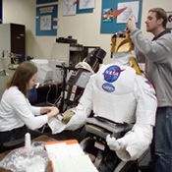
Occupations in this category require knowledge in a specialized field such as science, math, engineering, law, or accounting (depending on the specific position). These positions generally require a bachelor's degree or higher degree with major study in a specialized field. This group covers positions such as:

* Accounting, GS-510
* Aerospace Engineering, GS-861
* Biology, GS-401
* Computer Engineering, GS-854
* Computer Science, GS-1550
* General Engineering, GS-801
* Meteorology, GS-1340

Administrative and Management (24% of NASA's positions)
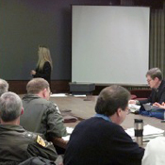
Occupations in this category require knowledge of principles, concepts, and practices associated with organizations, administration, or management. While these positions do not require specialized education (except for contracting positions), they do involve the type of skills (analytical, research, writing, and judgment) typically gained in a college-level education, or through a progressively responsible experience. This group covers positions such as:

* Administrative Specialist, GS-301
* Budget Analyst, GS-560
* Contract Specialist, GS-1102
* Information Technology Specialist, GS-2210
* Public Affairs Specialist, GS-1035

Clerical and Administrative Support (7% of NASA's positions)

Occupations in this category provide general office or program support duties such as preparing, receiving, reviewing, and verifying documents; processing transactions; maintaining office records; or locating and compiling data or information from files. This group covers positions such as:

* Accounting Technician, GS-525
* Clerk-Typist, GS-322
* Management Assistant, GS-344
* Office Automation Clerk, GS-326
* Procurement Clerk, GS-1106
* Secretary, GS-318

Technical and Medical Support (9% of NASA's positions)
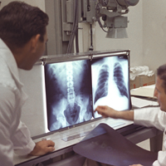
Occupations in this category support professional or administrative work. Duties require practical knowledge of techniques and equipment, gained through experience and/or specific training less than that represented by college graduation. This group covers positions such as:

* Electronics Technician, GS-856
* Engineering Technician, GS-802
* Meteorological Technician, GS-1341


Trades and Labor (<1% of NASA's positions)
Occupations in this category include trades or crafts positions, including skilled mechanical and electrical crafts, and unskilled, semi-skilled, or skilled manual-labor occupations. This group covers positions such as:

* High Voltage Electrician, WG-2810
* Instrument Maker, WG-3314
* Model Making, WG-4714
* Utility Systems Repair, WG-4742

Student Jobs and Internships
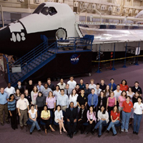
This category includes a variety of entry level or trainee positions, representing all of the occupational groups listed above. Positions are listed under this group if they are targeted towards students currently enrolled in high school or college. Positions in this category include:

* Cooperative Education Opportunities
* Temporary Student Positions
* Summer Employment Opportunities
* Internships

