ACTIVITY: ECLSS Diagram
Directions:
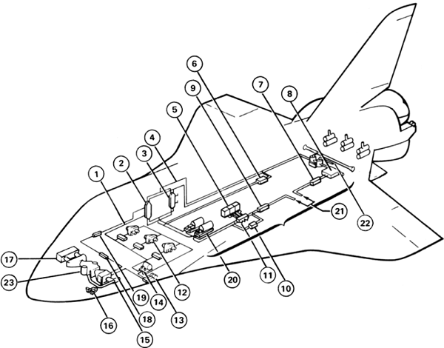
Label the following diagram to become more familiar with 23 ECLSS individual components on the orbiter and their locations.

1. ________________________________________ 13. ________________________________________
2. ________________________________________ 14. ________________________________________
3. ________________________________________ 15. ________________________________________
4. ________________________________________ 16. ________________________________________
5. ________________________________________ 17. ________________________________________
6. ________________________________________ 18. ________________________________________
7. ________________________________________ 19. ________________________________________
8. ________________________________________ 20. ________________________________________
9. ________________________________________ 21. ________________________________________
10. ________________________________________ 22. ________________________________________
11. ________________________________________ 23. ________________________________________
12. ________________________________________

Directions:
Label the following diagram to become more familiar with the 4 ECLSS subsystems and their functions.

