ANSWER KEY: ECLSS Diagram
Directions:
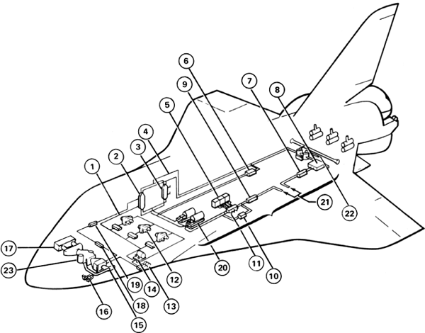
Label the following diagram to become more familiar with 23 ECLSS individual components on the orbiter and their locations.

- Water coolant loops  - Interchanger heat exchanger  - Payload heat exchanger  - Freon-21 coolant loops  - Fuel cell power plants  - Aft avionics bay and cold plates  - Ground support equipment heat exchanger  - Ammonia boiler  - Hydraulic heat exchangers to radiators  - Midbody cold plates  - Fuel cell heat exchanger to Freon-21 coolant loops  - Avionics bays 1, 2, and 3A heat exchangers, fans, and cold plates | - Inertial measurement units heat exchanger and fans  - Water pumps  - Cabin air-to-water heat exchanger  - Humidity water separators  - Cabin fans and check valve assemblies  - Potable water chiller heat exchanger  - Liquid-cooled garment heat exchanger  - Freon-21 coolant pumps  - To radiators  - Flash evaporators  - Carbon dioxide absorber

Directions:
Label the following diagram to become more familiar with the 4 ECLSS subsystems and their functions.

1. Atmospheric Revitalization and Pressure Control System (ARPCS)
2. Active Thermal Control System
3. Food, Water, and Waste Subsystem
