READING: ECLSS (Environmental Control and Life Support System)

The ECLSS is responsible for maintaining a comfortable environment for the astronauts while they are out of their space suits and in the orbiter's cabin. The orbiter's environmental control and life-support system purifies the cabin air, adds fresh oxygen, keeps the pressure at sea level, heats and cools the air, and provides drinking and wash water. The system also includes lavatory facilities. The cabin is pressurized to sea level (14.7 psi) with 21 percent oxygen and 79 percent nitrogen, comparable to Earth's atmosphere. The air is circulated through lithium hydroxide/charcoal canisters, which remove carbon dioxide. The canisters are changed on a regular basis.

Excess heat from the cabin and flight-deck electronics is collected by a circulating coolant water system and transferred to radiator panels on the payload bay doors where it is dissipated. The fuel cells produce about seven pounds of water each hour. It is stored in tanks, and excess water is dumped overboard. The lavatory unit collects and processes body waste and also collects wash water from the personal hygiene station. The lavatory unit, located in the mid deck area, operates much like those on commercial airlines but is designed for a weightless space environment.

- Water coolant loops
- Interchanger heat exchanger
- Payload heat exchanger
- Freon-21 coolant loops
- Fuel cell power plants
- Aft avionics bay and cold plates
- Ground support equipment heat exchanger
- Ammonia boiler
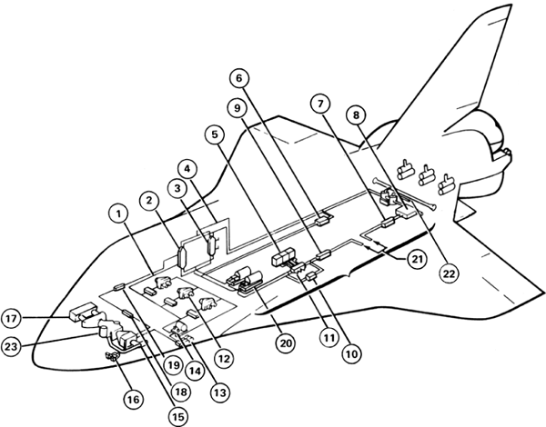
- Hydraulic heat exchangers to radiators
- Midbody cold plates
- Fuel cell heat exchanger to Freon-21 coolant loops
- Avionics bays 1, 2, and 3A heat exchangers, fans, and cold plates
- Inertial measurement units heat exchanger and fans
- Water pumps
- Cabin air-to-water heat exchanger
- Humidity water separators
- Cabin fans and check valve assemblies
- Potable water chiller heat exchanger
- Liquid-cooled garment heat exchanger
- Freon-21 coolant pumps
- To radiators
- Flash evaporators
- Carbon dioxide absorber

The Three Subsystems
The ECLSS provides a pressurized and livable environment for the orbiter’s crew. This environment is not only important for the crew, but it is essential to the protection and proper functioning of the onboard avionics. An additional function of the ECLSS is the management, storage, and disposal of water and crew waste. The ECLSS is subdivided into four main parts:
- Pressure Control System: maintains a pressure of 14.7 psia of a breathable mixture of oxygen and nitrogen in the crew compartment. Nitrogen also is used to pressurize wastewater tanks.
- Atmospheric Revitalization System: uses circulated air and water coolant loops to remove heat, control humidity, and purify the air in the cabin.
- Active Thermal Control System: uses two Freon loops to collect heat from the orbiter’s waste systems and transfer it overboard.
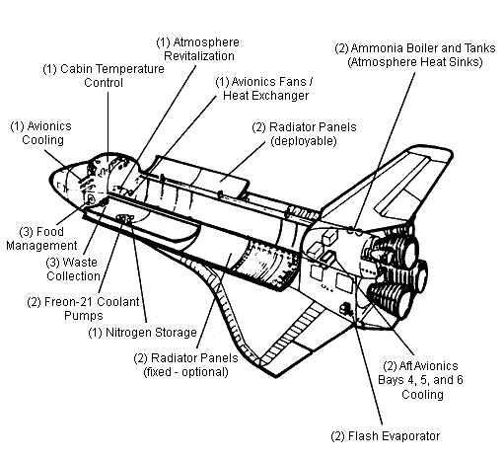
- Supply & Wastewater System: stores water that is produced by the fuel cells for use by the orbiter crew (drinking, cooking, and hygiene). It also stores liquid waste produced by the crew, as well as wastewater collected from the humidity separator. It has the ability to dump both supply and wastewater overboard.

Key:
1. Atmospheric Revitalization and Pressure Control System (ARPCS)
2. Active Thermal Control System
3. Food, Water, and Waste Subsystem
The ECLSS KLASS Console
The graphic below displays shows the part of the ECLSS responsible for maintaining a comfortable air temperature.
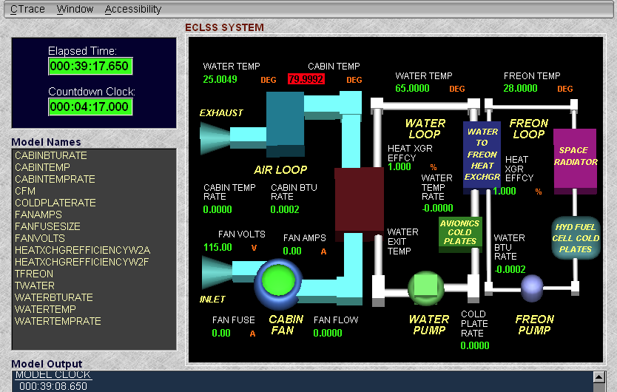

In the KLASS model of the ECLSS, you will notice that the display is set up in three different loops
- Freon Loop
- Water Loop
- Air Loop

Why is Freon spelled with an upper case “F”?
Freon is a trade name owned by DuPont. Therefore, it is a proper noun.

What is Freon?
Freon is a chemical that is excellent at absorbing heat. Because of this property, Freon has been used for many years in air conditioning units. The downside of Freon is that it is harmful to the environment. Because of this, many air conditioning companies have turned to alternative chemicals. However, it is still an important part of the Space Shuttle.

1. Freon Loop:
The Freon loop has three main parts and one that it shares with the water loop. The first part is the space radiator. Just like the radiator in your car, this radiator uses the cool temperatures of space to help release heat that is absorbed from the cabin.

The second part of the Freon loop is the hydrogen cell cold plate. This plate helps to absorb heat energy from the batteries that is used to power the orbiter while it orbits Earth. This is important because overheated batteries could quit working and have a serious negative impact on astronauts and orbiter.

As with most liquid based systems like the Freon loop, there must be some method of moving that liquid through the system. In this case, Freon is pumped through the system by the Freon pump.

The Freon pump is connected to the water loop by the water/Freon heat exchanger. Here, water and Freon don’t actually mix together, the pipes they are in run right next to each other. By doing this, heat energy that has been absorbed by the water at it passed through the loop can be passed on and absorbed by the Freon. By doing this, the water temperature will be lowered.

2. Water loop:
Just like the Freon loop, the water loop is responsible for helping to cool off the orbiter by absorbing heat from various sources and passing that heat energy to the Freon loop. Once water temperatures are lowered, the cool water can be cycled through the water loop to help cool off things such as the orbiter’s avionics.

The avionics pass heat energy to the water loop at the avionics cold plate. Because the avionics are one of the major sources to heat in the orbiter, it is very important to help keep these devices cool. This is important for the safety and proper function of the orbiter and safety and comfort of the crew.

Just like the Freon loop, water is moved through the water loop with the aid of a pump.

3. Air loop:
The air loop is what provides cool air to the crew of the orbiter. Heat energy is absorbed from the air into the water loop. The air loop is unique in that it is an open system. This means that the cabin of the orbiter is part of the loop.

This air inside the cabin is sucked into the loop so that it may pass by the water loop. This cool air is then pushed by a fan back out into the cabin. This allows the astronauts to feel cooler and more comfortable while working in space.

Avionics: computers and other electronic systems used to operate and maintain the orbiter and astronauts during flight.
Important things to know for the KLASS ECLSS
Did You Know?
- It would take 143 BTU to melt one pound of ice.

- Fuses are identified by their wattage.

- Efficiency is always measured by percent.

BTU: A BTU, or British Thermal Unit, is defined as the amount of heat needed to raise the temperature of water one degree Fahrenheit.

Conversion factors:

1 watt = 3.41 BTU/hr

1 BTU = 1,055 joules

Ohm’s Law: Ohm created a mathematical relationship between voltage and current as electricity passes through a conductive material. He established an equation:

I = V / r

where:
I = the measurement of current in amps
V = the measurement of voltage given as volts
r = is the measurement of resistance given in ohms

Before you begin running the KLASS simulation for the ECLSS, you need to establish the r for air loop using the information from the fan (fan volts and fan amps).

Temperature conversions:
C = (F-32) / 1.8
F = (C x 1.8) + 32
K = C + 272

Efficiency: The easiest way to define efficiency is to compare what goes into a system to what comes out of a system. If what goes in is equal to what comes out, then the system is said to be 100% efficient. If something is lost, then it would be less then 100%.

