` READING: The External Tank

The External Tank (ET) is the largest of the three main parts of the Shuttle system. When fully loaded, it becomes the heaviest element of the Shuttle, increasing from 66,000 pounds to 1,655,600 pounds. The 153.8 feet (47 meters) tall ET has a diameter of 27.6 feet (8.4 meters).

The ET is divided into three major components:
- Liquid Oxygen Tank (LOX or LO2)
- Intertank (Helium and ET Instrumentation)
- Liquid Hydrogen (LH2)
2
3
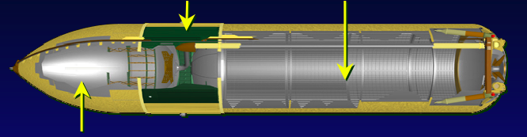
1
Liquid Oxygen Tank. The liquid oxygen tank is made out of aluminum monocoque and operates in a pressure range of 20 to 22 psig (pressure per square inch gauge). The tank contains anti-slosh and anti-vortex structures to reduce fluid motion during launch and ascent into space. The tank feeds into a 17-inch diameter line that transports the liquid oxygen through the intertank, then outside the ET to the Space Shuttle’s main engines (SSME). The 17-inch diameter feed line permits liquid oxygen to flow at approximately 2,787 pounds per second, with the SSMEs operating at 104 percent (has a maximum flow of 17,592 gallons per minute). The liquid oxygen tank's double-wedge nose cone reduces drag and heating, contains the vehicle's ascent air data system, and serves as a lightning rod. The liquid oxygen tank's volume is 19,563 in cubic feet (143,351 gallons), 331 inches in diameter, 592 inches in length, and 12,000 pounds in weight when empty (1,361,936 pounds full).
Keyword Review
Monocoque: A type of design in which structural load is supported using an object's external skin. In other words, the skin supports the structure.

Semimonocoque: A type of monocoque design that has the skin reinforced by longitudinal members. In other words, the skin is reinforced by a complete framework of structural members.

Liquid hydrogen: A common liquid rocket fuel. However, it has a low density of 70.8 kg/m³ so storage tanks for it have to be quite large.
psig: A measure of pressure relative to the surrounding atmosphere. In comparison, psia (pounds per square inch absolute or actual) measures pressure relative to a vacuum.
Anti-vortex: Devices that prevent swirling tornado-like formations that are caused, for example, when water goes down a drain. Sometimes, you can find these devices in swimming pools.

Intertank. The unpressurized intertank is a steel and aluminum semimonocoque cylindrical structure that is joined on either end to the liquid oxygen and liquid hydrogen tanks. The intertank houses ET instrumentation components and contains an umbilical plate that allows for the detection (especially of hazardous gases) and release of excess gas supplies (mainly boiled off hydrogen). The intertank is 270 inches long, 331 inches in diameter and weighs 12,100 pounds.

Liquid Hydrogen Tank. The liquid hydrogen tank is an aluminum semimonocoque structure with an operating pressure range of 32 to 34 psia (pounds per square inch (absolute)). The tank contains an anti-vortex baffle and siphon outlet to transport the liquid hydrogen from the tank through a 17- inch line. The liquid hydrogen feed line flow rate is 465 pounds per second with the SSMEs at 104 percent (has a maximum flow of 47,365 gallons per minute). The liquid hydrogen tank is 331 inches in diameter, 1,160 inches in length, and 53,518 cubic feet (385,265 gallons) in volume. It has a dry weight of 29,000 pounds (227,641 pounds full).

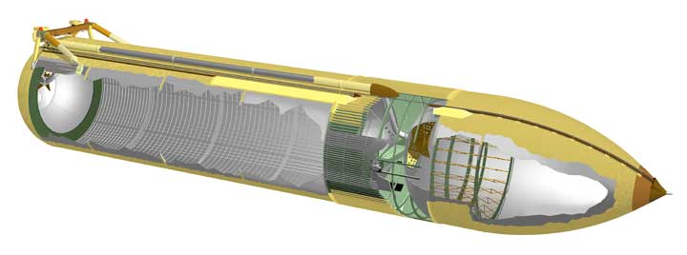

Three for one!
The ET is really 3 tanks. The top tank holds liquid oxygen, the middle tank hold helium and the external tank instrumentation, and the bottom tank holds liquid hydrogen. Helium is an element that does not react with oxygen or hydrogen. The purpose of this middle tank is to keep oxygen and hydrogen from reacting and exploding if there is a leak in the liquid oxygen or liquid hydrogen tank. After the oxygen and hydrogen tanks are empty from running the main engines, helium is pumped into the main engines to flush out the fuel.
External Tank Stats
Weight
Empty: 78,100 pounds
Propellant: 1,585,379 pounds
Gross: 1,667,677 pounds

Propellant Weight
Liquid oxygen: 1,359,142 pounds
Liquid hydrogen: 226,237 pounds
Gross: 1,585,379 pounds

Propellant Volume
Liquid oxygen tank: 143,060 gallons
Liquid hydrogen tank: 383,066 gallons
Gross: 526,126 gallons

Quenching the SSME’s Thirst
The ET’s liquid hydrogen (fuel) and liquid oxygen (oxidizer) supply the three Shuttle main engines, located in the orbiter, during launch and ascent into space. Fuel from the ET begins to be consumed 6 seconds prior to launch of the Shuttle as the main engines power up to 90 percent. After two minutes of the ascent into orbit, the Shuttle’s SRBs are jettisoned from the ET and descend into the Atlantic Ocean to be captured and reused. The ET continues to supply fuel to the SSMEs for approximately another six and a half minutes. When all of the liquid fuel is consumed and the Shuttle approaches its orbit, the ET is jettisoned off. As it passes back through the atmosphere, it begins to disintegrate. Any parts not completely destroyed fall into remote areas of the ocean and are never recovered or reused.

Why is Hydrogen used as rocket fuel?
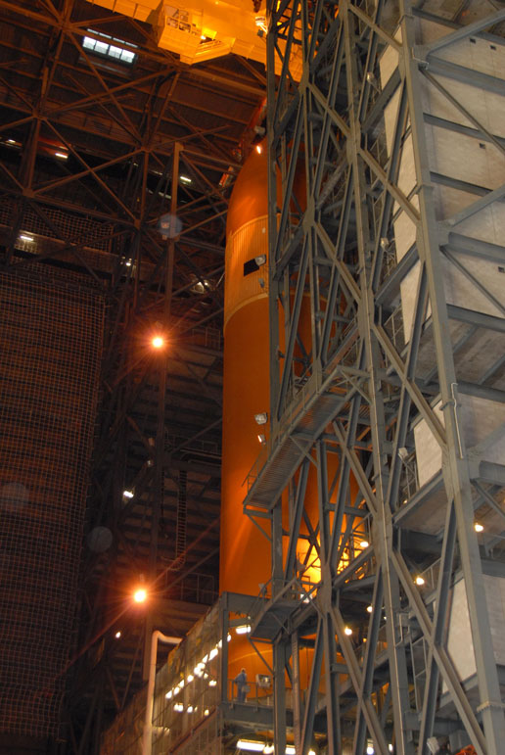
Hydrogen is the lightest chemical element and is found naturally in the molecular H₂ form. At normal temperatures and pressures, it is a gas. When cooled to very low temperatures (-252.882º C) and pressurized, it exist as a liquid.

Hydrogen is able to react chemically with most other elements. In air, it is highly flammable, burning at concentrations as low as 4% H₂. When mixed with oxygen, hydrogen explodes upon ignition. A unique property of hydrogen is that its flame is nearly invisible in air.

Is Oxygen an Oxidizer?
An oxidizer is a chemical which a fuel requires to burn. Most types of burning on Earth use oxygen. However, in space there is no oxygen or other oxidizers so rockets need to carry their own oxidizers. Usually, they are carried in a different tank than the fuel. Liquid oxygen is often use as an oxidizer in rocket propulsion.

When sitting on the launch pad, the oxygen tank’s pressure must be regulated on the oxygen tank because temperature changes can causes the liquid oxygen to revert to gas. Pressure is vented from the beanie cap.

Strength and Weight
A new generation of Super Lightweight Tanks is now being produced. Vital to building and supplying the International Space Station, they weigh some 7,500 pounds less than previous ETs. Design changes and use of an aluminum-lithium alloy result in an overall weight of 58,500 pounds. The first Super Lightweight Tank made its initial flight on June 2, 1998, when it successfully powered Space Shuttle mission STS-91 into space. The metal skin of the Super Lightweight Tank is less than one-half inch thick, yet it holds more than 1.6 million pounds of propellants and withstands the rigors of launch and flight while absorbing most of the seven million pounds of thrust loads. The ratio of the tank's weight to the weight it carries is about 1:27. A standard pickup truck's weight-to-cargo ratio is 3:1. If an aluminum soft drink can was expanded to the size of the ET, its walls would be about as thick as the tank's skin, but it would not be nearly as strong. Aluminum used in the tank, however, is not the same kind of aluminum used to make soft drink cans. The aluminum and steel alloys from which the tank is made contain some exotic sounding substances that contribute to the strength of the metal: manganese, titanium, columbium, tantalum, and vanadium.

The ET Console
The ET console monitors the flow of liquid oxygen and liquid hydrogen to the main engines. As an ET engineer, your job is to monitor the fuel level, fuel flow, and pressure in the oxygen tank.

When the KLASS simulation begins, your role is an important one. One of the responsibilities of your team will be to ensure the oxygen tank pressure remains within a safe range. Using the GOX RELF (Oxygen Relief) button in the upper-right corner of the console, you will be releasing pressure (turning the button to GOX RELF ON) when it gets out of range. When pressure comes back into range, you will need to watch to make sure it doesn’t fall too low. If it does, you’ll need to cap the vent by pressing GOX RELF button so that is displays GOX FELF OFF (pressure relief off). When the psi value is red, you’ll need to act in order to bring it into its acceptable range.

Below, the different parts of the ET that you’ll be monitoring are labeled. One special feature of the ET Console is that it also monitors Total Mass Flow and Turbo Flow for the two propellants, just like in the SSME Console.

