Endeavour's Booster View 03.11.08

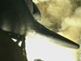

http://www.nasa.gov/mp4/218484main_ksc_sts123_camera_views.mp4

Natural sound only.

