READING: OBS

Operational Bioinstrumentation System (OBS)
Traveling to and from space is one of the most physically demanding, yet thrilling, activities someone could experience. That is why it is very important for NASA to monitor the health of astronauts during launch and landing of the Space Shuttle.

Although the human body is a very complex machine made up of many unique systems, NASA only monitors the vital signs of two astronauts during each individual mission. Astronauts spend years going through physical training and evaluation, and therefore, they are in top physical condition. By monitoring the astronauts’ vital signs during launch and landing of the Space Shuttle, NASA can be sure that the astronauts are experiencing normal changes to their bodies.

Body Temperature
The average body temperature of a healthy person is between 36 to 37 degrees Celsius, or 96.8 to 98.6 degrees Fahrenheit. Often times, a high increase in body temperature can be an indicator of infections. Just think about the last time you had a fever, chances are you were sick for a couple of days. That is because your body raises its temperature to try and kill any “bug” that might be causing you to be sick. During the day, our bodies also experience slight temperature changes. These changes can be due to a number of causes such as physical activity and the temperature of the environment around us.

Heart Rate
For a healthy adult, the resting heart rate can range from 60 to 100 times a minute. The age and health of an individual can impact the heart rate. Typically, a younger and/or healthier person will have a lower resting heart rate. The heart rate of an active person can go as high as 220 beats per a minute. Sometimes a rise in heart rate can be the result of a brief moment of excitement. The last time you scared your mom, chances are her heart rate increased.
Keyword Review
Heart rate: The measurement of how many times per a minute that a heart beats.

Blood pressure: The measurement of the force blood puts on the walls of our arteries.

Indicator: Something that shows or points to a specific result.
Respiratory rate: The number of times that we inhale, or breathe in during a given time.

Whether resting or exercising, your heart beats to move oxygen rich blood throughout the body and oxygen poor blood back to the lungs. The more you exercise, or the more excited you get, the more oxygen your body needs.

Blood Pressure
The unit of measurement for blood pressure is mmMg, or millimeters of mercury. Anytime you observe someone give his or her blood pressure, you will witness two numbers (i.e., 120/80, or said as 120 over 80). This is because our hearts have two “cycles” that are measured. The first number represents the systolic measurement, or the period of time when the chambers of the heart contract. The second number is the diastolic measurement, or when the heart relaxes after contraction. The measurement of 120/80 is a normal value for a healthy adult.

Vital signs
During the launch and landing of the Shuttle, the astronauts are monitored for four main things:
- body temperature
- heart rate or pulse
- blood pressure
- respiratory rate

Temperature of the environment: If your body temperature goes too low, you are said to have hypothermia. If your temperature goes too high, you are said to have hyperthermia. If a person is exposed to either one of these conditions for too long, he or she can die. Also note that these two conditions can be caused by a number of diseases.

Respiratory Rate
The respiratory rate varies greatly from person to person and from situation to situation. Typically, younger and healthier adults will have a lower respiratory rate.

Additional Information
Did You Know?
NASA research and development has lead to many medical instruments, devices, and tools that save lives on a daily basis. NASA “spinoffs” have lead to lifesaving devices such as artificial hearts.
For the KLASS launch countdown activity, the student(s), who monitors the OBS screen will find one other value on the screen. This value is the blood oxygen level. Since oxygen is what our bodies need to survive, this value is very important. In a healthy individual, the blood oxygen should be between 90 to 100 percent. If the value falls below 90, the body would not be getting the oxygen it needs to stay healthy.

Can you make a prediction?
Can you make a prediction as to what would happen to your heart rate, respiration rate, blood pressure, blood oxygen level, and body temperature if you were to run a mile? How about five miles? What if you were sitting on the couch watching television? And what would they be if you were sleeping?

OBS on Launch Day
The OBS launch team at KSC consists of many types of individuals such as medical device technicians, biometric engineers, physicians, and emergency medical responders. On launch day, KSC is fully staffed with 15 medical teams that include additional military physicians, medi-vac helicopter teams, ER doctors, and paramedics in safety and rescue mode. OBS is represented in the firing room, sitting with the ECLSS team. If you are interested in a career like this, you should pursue medical and/or electrical engineering degrees.
OBS Console
The OBS console displays an electrocardiograph of two designated flight crewmembers. For these astronauts, the console also displays pulse, respiration, oxygen level, blood pressure, and temperature.

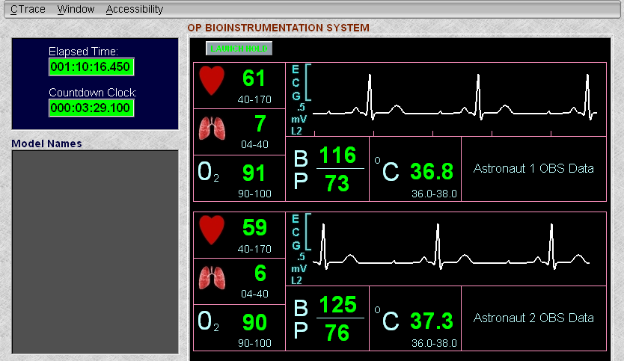

Crew Equipment: OBS
The OBS provides an amplified electrocardiograph analog signal from either of two designated flight crew members to the orbiter avionics system, where it is converted to digital tape and transmitted to the ground in real time or stored on tape for dump at a later time. The designated flight crew members wear the OBS during the ascent and entry phases. On-orbit use will be limited to contingency situations.

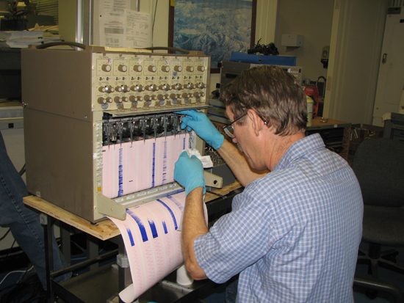
The OBS electrodes are attached to the skin with electrode paste to establish electrical contact. The electrode is composed of a plastic housing containing a non-polarizable pressed pellet. The housing is attached to the skin with double-sided adhesive tape, and the pellet contacts the skin. There are three electrodes on the harness marked LC (lower chest), UC (upper chest), and G (ground).

The ECG signal conditioner is a hybrid microcircuit with variable gain (adjusted for each crew member before flight). It provides a zero-to 5-volt output and has an on/off switch within the input plug, which is actuated when the intravehicular activity biomed cable is plugged in. The unit has batteries that will not be replaced in flight.

The IVA biomed cable connects to the signal conditioner and is routed under the IVA clothing to connect to the biomed seat cable. The biomed seat cable is routed to one of the biomed input connectors located on panel A11, A15, or M062M. Rotary control switches on panel R10 provide circuits from the biomed outlets to the orbiter's network signal processor for downlink or recording. The two rotary switches on panel R10 are biomed channel 1 and channel 2. Extravehicular activity positions provide circuits for the EVA UHF transceiver.

The electrode application kit contains components to aid in the application of electrodes. The components include wet wipes, double-sided adhesive tape, overtapes, electrode paste, and a cue card illustrating electrode placement.

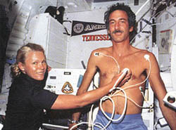
Astronauts use the echocardiograph to record images of the heart as the body adapts to microgravity.

The shift of body fluid toward the head during spaceflight may initiate cardiovascular adaptation to space. Determining venous pressure by measuring blood flow in the jugular vein may help to define the timetable for fluid shifts and space adaptation.

To help solve the mysteries of human adaptation to space, crewmembers serve as test subjects. To the right, a Spacelab 1 payload specialist exercises while instruments measure his heart's operation in microgravity.

