ACTIVITY: SSME Propellant Flow

Directions:
In the corresponding spaces below, provide the specific name for each valve, pump, and preburner. Also describe the role of each in the main engine’s propellant flow. Then, for each pump, indicate the input and output pressure of the liquid propellant that passes through it.

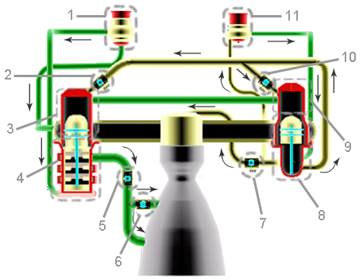

1. ______________________________________________________________________________________
_________________________________________________________________________________________
_________________________________________________________________________________________
Pressure (In/Out): __________________________________________________________________________
2. ______________________________________________________________________________________
_________________________________________________________________________________________
_________________________________________________________________________________________
3. ______________________________________________________________________________________
_________________________________________________________________________________________
_________________________________________________________________________________________
4. ______________________________________________________________________________________
_________________________________________________________________________________________
_________________________________________________________________________________________
Pressure (In/Out): __________________________________________________________________________
5. ______________________________________________________________________________________
_________________________________________________________________________________________
_________________________________________________________________________________________
6. ______________________________________________________________________________________
_________________________________________________________________________________________
_________________________________________________________________________________________
7. ______________________________________________________________________________________
_________________________________________________________________________________________
_________________________________________________________________________________________
8. ______________________________________________________________________________________
_________________________________________________________________________________________
_________________________________________________________________________________________
Pressure (In/Out): __________________________________________________________________________
9. ______________________________________________________________________________________
_________________________________________________________________________________________
_________________________________________________________________________________________
Pressure (In/Out): __________________________________________________________________________
10. ______________________________________________________________________________________
_________________________________________________________________________________________
_________________________________________________________________________________________
11. ______________________________________________________________________________________
_________________________________________________________________________________________
_________________________________________________________________________________________
Pressure (In/Out): __________________________________________________________________________

