ANSWER KEY: SSME Propellant Flow

Directions:
In the corresponding spaces below, provide the specific name for each valve, pump, and preburner. Also describe the role of each in the main engine’s propellant flow. Then, for each pump, indicate the input and output pressure of the liquid propellant that passes through it.

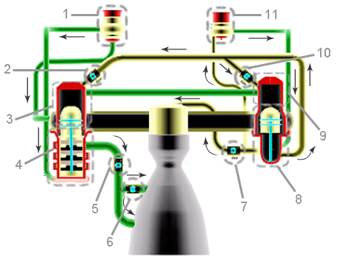

1. Low Pressure Fuel Turbo Pump (LPFTP): The 15,000 rpm turboinducer of the HPFTP increases pressure
of the LH2 from 30 to 250 psia to help prevent cavitation of the LPFTP. Pressure (In/Out): 30 psia / 250
psia
2. Fuel Pump Oxidizer Valve: Controls the flow of LOX into the Fuel Preburner, affecting turbine speed.
3. Fuel Preburner: Produces hot gas that passes through the turbines to generate power for the HPFTP.
4. High Pressure Fuel Turbo Pump (HPFTP): The 35,000 rpm centrifugal pump increases pressure from 250
to 6,000 psia. Pressure (In/Out): 250 psia / 6,000 psia
5. Main Fuel Valve: Controls fuel entering the Combustion Chamber.
6. Chamber Coolant Valve: Regulates the amount of gaseous hydrogen used to control engine temperature.
7. Main Oxidizer Valve: Controls LOX flow into the Combustion Chamber.
8. High Pressure Oxidizer Turbo Pump (HPOTP): The 30,000 rpm centrifugal pump increases LOX pressure
from 400 to 4,500 psia. Pressure (In/Out): 400 psia / 4,500 psia
9. Oxidizer Preburner: The Oxidizer Preburner’s boost pump increases the LOX pressure from 4,500 to 7,500
psia. Pressure (In/Out): 4,500 psia / 7,500 psia
10. Oxidizer Pump Oxidizer Valve: Controls flow of LOX into the Oxidizer Preburner, affecting turbine speed.
11. Low Pressure Oxidizer Turbo Pump (LPOTP): The 5,000 rpm turbine of the LPOTP increases LOX
pressure from 100 to 400 psia to help prevent cavitation of the HPOTP. Pressure (In/Out): 100 psia / 400
psia

