ANSWER KEY: SSME Valves HPFTP

Directions:
After reading Understanding the Valves used with the HPFTP, complete the activities below.
- What if the FPOV had a leak? How would you calculate flowrate? Would you use the same flowrate formula or would you have to modify it?
For a leaky valve, you only need to add a “leak” constant to capture the extra leaked mass. We just have to be sure the leak itself is constant:
For example, if all valves were leaking but at different rates, the HPFTP flowrate would be expressed as:
$\text{flowrate}=\left({\text{OxidizerFlowrate}}_{\text{max}}×\text{OV}\text{\%}+ℓ_{1}\right)+ \left({\text{FuelFlowrate}}_{\text{max}}×\text{FV}\text{\%}+ℓ_{2}\right)$
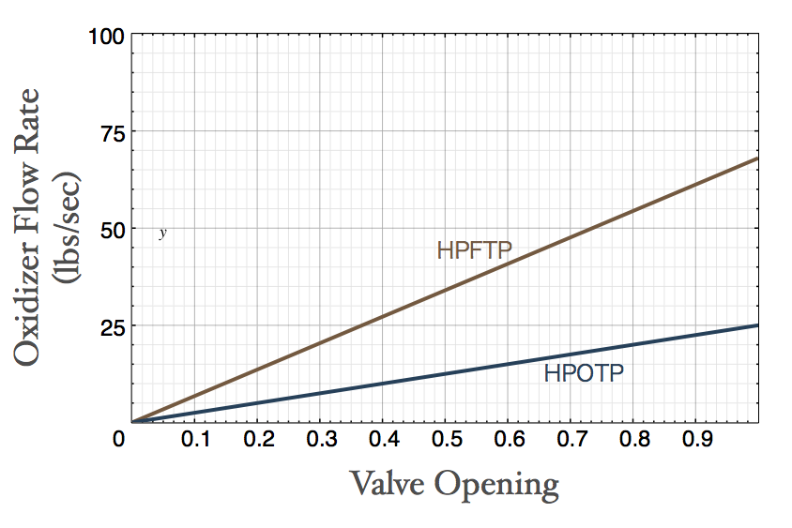
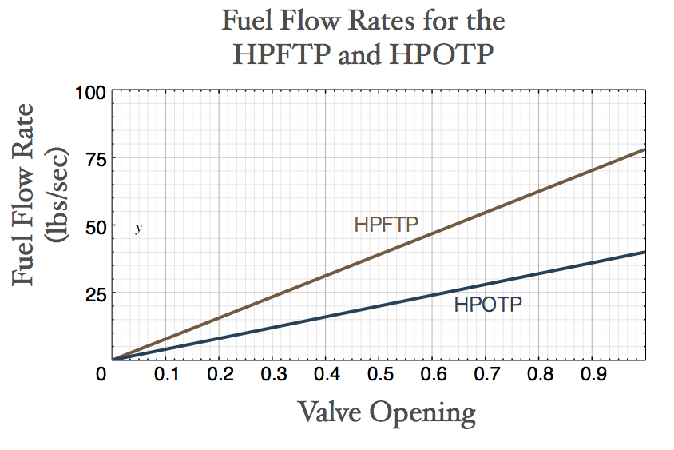
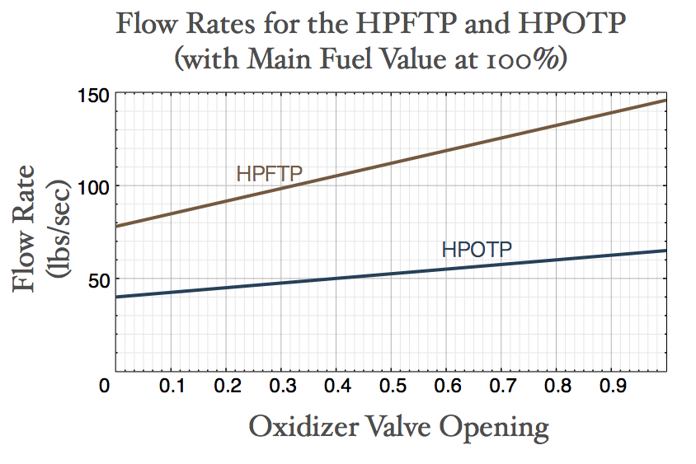
- Both the oxidizer and fuel are related linearly to flowrate.
a. Can you graph the oxidizer flow rate for either the HPFTP or HPOTP as a function of how much the oxidizer valve is open? (Note: the maximum oxidizer flow rate for the HPFTP is 68 and for the HPOTP it is 25.)
b. Can you graph the fuel flow rate on the same set of axes? (Note: the maximum oxidizer flow rate for the HPFTP is 78 and for the HPOTP it is 40.)
c. Graph the total flow rate for the HPFTP and HPOTP with the Main Fuel Valve kept constant at 100%.
d. How did you determine the scale for the Flow Rate (y) axis?
Since both flowrates have positive slopes, solving both for valve opening = 1, and taking the maximum of the two gives us a maximum flowrate (y-value).
e. Can you graph either the HPFTP or HPOTP flowrate as a function of both fuel and oxidizer valve opening?
You only can graph fuel or oxidizer on two axes, not both. To graph both you would need an additional axis to graph a function with two independent variables, fuel and oxidizer.
- Using the graphs or equations above, determine which turbopump would experience the greatest change in flowrate by an increase in the Main Fuel Valve opening: the HPFTP or HPOTP?
Comparing the steepness of the slopes, we can see that the HPFTP’s flow rate will increase more for a change in valve opening. We also can see this in the equations’ slopes.
- With each turbopump’s oxidizer valve set at 100%, can you graph the difference between the HPFTP and HPOTP’s flow rates as a function of Main Fuel Valve opening?
We’ll take the difference between the HPFTP and the HPOTP’s flowrates to get an equation that represents the difference.
$\begin{aligned}{\text{flowrate}}_{\text{difference}}={\text{flowrate}}_{\text{HPFTP}}−{\text{flowrate}}_{\text{HPOTP}} \\ =\left(\text{68}x+\text{78}\right)−\left(\text{25}x+\text{40}\right) \\ =\text{43}x+\text{38}\end{aligned}$
