READING: SSME

Understanding the Space Shuttle Main Engines (SSME)
The SSME is about 8 feet (2.5 meters) wide by 14 feet (4.3 meters) tall and weighs around 7,000 pounds. Each of the three engines is connected to the External Tank (ET) with piping and valves, which are monitored with sensors. Propellants pass through a series of turbopumps where they are pressurized and heated. There are two types of propellants: oxidizer and fuel. The oxidizer is liquid oxygen (LOX) and the fuel is liquid hydrogen (LH2). Each engine consumes about 890 lbs of LOX and about 150 lbs of LH2 each second in a 6:1 oxidizer-to-fuel ratio. The hydrogen is eventually mixed with the oxygen in the combustion chamber where it is ignited and the fuel is burned, creating energy that exits from the engine through the nozzle. This energy increases until it is enough to push the Shuttle System into the air. We measure this energy as thrust.
SSME Quick Facts
- Each of the three engines costs $50 million.

- Each engine can produce 400,000 lbs of thrust.

- The SSME has a temperature ranging from
-423ºF to 6000ºF.

- The hydrogen and oxygen turbine pumps could drain a family pool in 25 seconds. They also produce the horsepower equal to 39 locomotive engines.

What are the parts of the SSME, and what do they do?
Valves between the external fuel tank and the SSME control the amount of fuel that goes to the low-pressure oxidizer and fuel turbopumps. These are axial-flow pumps driven by turbines. The low-pressure liquid oxygen turbopump (LPOT) is an axial-flow pump driven by a six-stage turbine and powered by liquid oxygen. It increases the LOX pressure from 100 to 422 psia. The low-pressure fuel turbopump (LPFT) is driven by a two- stage turbine powered by gaseous hydrogen. It increases LH2 pressure from 30 to 300 psia.

These low-pressure turbopumps increase the pressure of the oxidizer or fuel passing through them in order to prevent cavitation in the high-pressure oxidizer and fuel turbopumps. Cavitation can occur if the propellant’s pressure changes or its temperature increases enough to form vapor bubbles. If these bubbles can’t escape, they implode, causing damage to the turbine blades.

After passing through the low-pressure pumps, the propellants pass through a pair of high-pressure pumps where the propellants’ pressure is increased further. These centrifugal pumps also are turbine driven and include pre-burners that heat some of the liquid propellant, producing a hot high-pressure gas to drive the turbines. While the oxidizer and fuel pressure is increased to thousands of pounds per square inch by the turbopumps, some of the fuel is used as a coolant for the nozzle. Oxygen that is not needed for the combustion chamber is pumped back to the external tank to pressurize the liquid oxygen tank.

The combustion chamber is where gaseous hydrogen and liquid oxygen are mixed and ignited. A small spark igniter is located in the center of the chamber. Once the engines are started, the igniter is no longer needed because the combustion process is self-sustaining.

The nozzle is bell shaped and attached to the main combustion chamber. It is 113 inches long and has an outside diameter at the back of the orbiter of 94 inches. The nozzle directs the energy created from the burning of the fuels. This thrust is what will lift the Shuttle off the ground and push it into space.

Below is the console view of the Main Engine. The pink piping carries the fuel (hydrogen), and the blue piping carries oxidizer (oxygen).

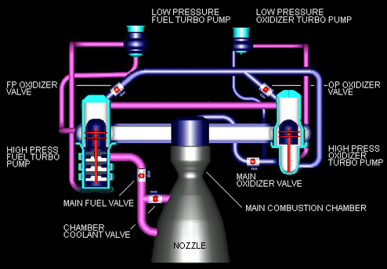
SSME Component Relationships
The diagram shows the relationships among SSME components. Each arrow points from an input to a calculated result. For example, Low Pressure Oxidizer Turbopump RPM is an input to LOX Flow.
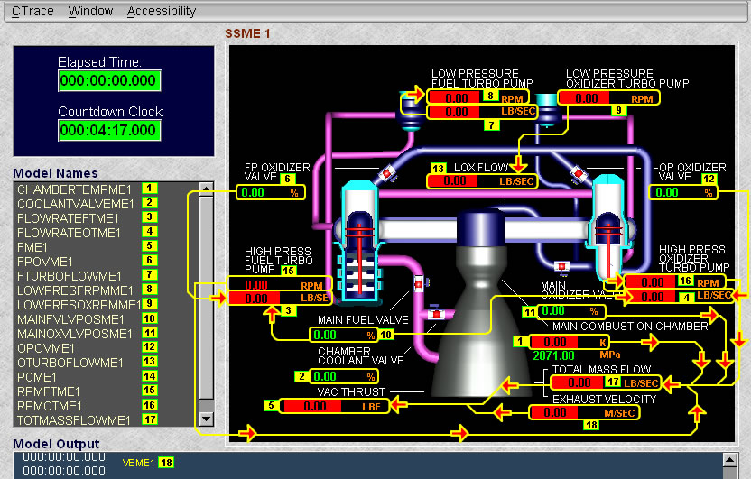

SSME Valves
Valves can be opened and closed by applying a percent value to them. To apply a new value to any valve
1. Right click on its percent value 2. Choose Apply from the pop-up menu 3. Enter the new value from 0 to 100 4. Press Send
You should see the new value on the console display.

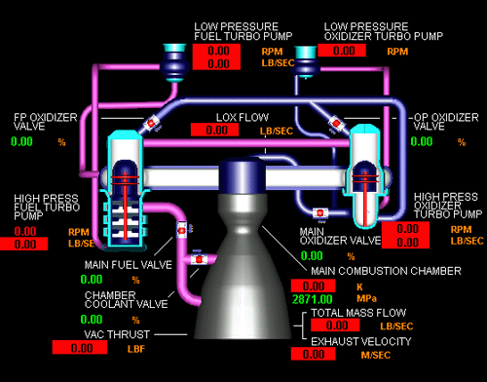
FP Oxidizer Valve controls Oxidizer (LOX) to the HPFTP
Main Fuel Valve controls fuel (LH2) to the HPFTP and HPOTP
Chamber Coolant Valve controls temperature in the Combustion Chamber
OP Oxidizer Valve controls Oxidizer (LOX) to the HPOTP

Main Oxidizer Valve controls oxidizer to the engine’s main injector
Understanding the Valves used with the HPFTP
Two valves are used to control the speed of the High-Pressure Fuel Turbopump (HPFTP). The speed of the turbine is controlled by the amount of fuel and oxidizer that is burned in the turbine. As the turbine spins faster, the more fuel is pumped.
Did You Know?
- The HPFTP delivers as much horsepower as 28 locomotives.
- The HPFTP generates 70 hp per pound, while a typical aircraft jet engine generates 3 hp per pound.
- The counting of how many times an item goes around a center point per minute is called revolutions per minute (rpm). A second hand on a clock goes around a clock face 1 time in a minute. Its rpm is 1.
- The HPFTP operates at approximately 35,360 rpm.
- The FPOTP operates at approximately 28,120 rpm.

The high-pressure turbopumps provide fuel and oxidizer to the combustion chamber. These pumps run at very high speeds up to 35,000 rpm. There are two parts to these pumps. The first part is the pump that gets the fuel or oxidizer coming from the low-pressure pumps and increases the pressure – flow volume. The second part is the turbine; it is an engine that burns fuel and oxidizer. The more fuel the turbine burns the faster the turbine engine spins. This spinning turns the pumps. As the pumps increase speed, they pump more fuel and oxidizer into the turbine where they are ignited. This mix of burning hydrogen and oxygen is pushed into the combustion chamber where more oxygen is added to the fuel, and it is ignited and burned. This creates the energy to launch the Shuttle.

Controlling the HPFTP and the HPOTP
By adjusting the amount of fuel and oxidizer burned in the turbine engine of the pump, you control the amount of fuel allowed to go to the HPFTP and HPOTP. Not enough fuel or oxidizer means you will not have sufficient energy to launch the Shuttle. The turbine rpm is controlled by the amount of fuel and oxidizer you give it, just like a car. When you step on the gas pedal, the faster you go; take your foot off of the gas pedal and the slower you go. The astronauts do not have a gas pedal in the Shuttle system, so this is how NASA controls the engines.

Using Valves
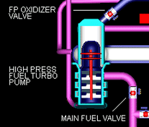
The control of fuel and oxidizer going to the HPFTP and HPOTP is maintained with three valves: the Main Fuel Valve, the Fuel Pump Oxidizer Valve (FPOV), and the Oxidizer Pump Oxidizer Valve (OPOV). The Main Fuel Valve and FPOV control the HPFTP. Main Fuel Valve, and the (OPOV) control the HPOTP. As you can see, the Main Fuel Valve controls both high-pressure turbopumps, while each turbopump has its own oxidizer valve.

Opening and closing the oxidizer and fuel valves changes the amount of propellant driving the turbopumps. This means more fuel is burned in the turbopumps preburner, which produces hot expanding gas to drive the turbines. As the turbines speed up, they move more LH2 and LOX through the engine and into the Combustion Chamber. This movement of LH2 or LOX is measured in pounds per second (lb/sec) and can be seen on the SSME console next to the HPFTP or HPOTP. You can calculate the amount of mass coming out of the HPFTP or HPOTP by multiplying the maximum flow rate by the percentage the valve is opened.

Using math
flow rate (in lb/sec) = maximum flow times the percent of valve opening.
When determining the flow rate for either high-pressure turbopump, you will need to include both an oxidizer valve (OV) and the fuel valve (FV).
$$\text{flowrate}=\left({\text{OxidizerFlowrate}}_{\text{max}}×\text{OV}\text{\%}\right)+ \left({\text{FuelFlowrate}}_{\text{max}}×\text{FV}\text{\%}\right)$$

