ACTIVITY: Weather Console (Weather Technician)

Big Question: Based on the wind speed and direction will the weather clear the launch pad and the flight path in time to launch?
Use the weather data from the wind speed conversion sheet to look at the radar to determine if the weather will clear the launch pad and the flight path in time to launch. Share your information with the meteorologist to determine whether the weather conditions will permit, delay, or scrub the launch.
Time | Convert wind from kts to miles/hr | Multiply mi/hr to mi/(fraction of the hour) of launch to get the number of miles the weather will move before the launch |  | Record wind direction | Observe radar and weather spokes. Will weather clear in time to launch? Yes/No
Example | 15kt x 1.1508 =  17.262 mi/hr | 17.262 X 20/60=  17.262 X .33 = | 5.23 miles | N to S | Yes
 | _____ kt x 1.1508 =  _______ mi/hr | 17.262 X _____/60=  17.262 X _____ = | _______ miles
 | _____ kt x 1.1508 =  _______ mi/hr | 17.262 X _____/60=  17.262 X _____ = | _______ miles
 | _____ kt x 1.1508 =  _______ mi/hr | 17.262 X _____/60=  17.262 X _____ = | _______ miles
 | _____ kt x 1.1508 =  _______ mi/hr | 17.262 X _____/60=  17.262 X _____ = | _______ miles
 | _____ kt x 1.1508 =  _______ mi/hr | 17.262 X _____/60=  17.262 X _____ = | _______ miles
 | _____ kt x 1.1508 =  _______ mi/hr | 17.262 X _____/60=  17.262 X _____ = | _______ miles
 | _____ kt x 1.1508 =  _______ mi/hr | 17.262 X _____/60=  17.262 X _____ = | _______ miles
 | _____ kt x 1.1508 =  _______ mi/hr | 17.262 X _____/60=  17.262 X _____ = | _______ miles
 | _____ kt x 1.1508 =  _______ mi/hr | 17.262 X _____/60=  17.262 X _____ = | _______ miles

How to read direction and distance using radar data (sent from the Melbourne NWS Station):
Use the legend to understand the radar image. When you are charting speed and direction use the spokes and range rings. The range rings start 10 miles from Melbourne moving out toward the KSC Launch Pad. There are 5 miles between each range ring.
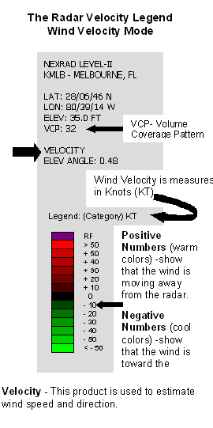
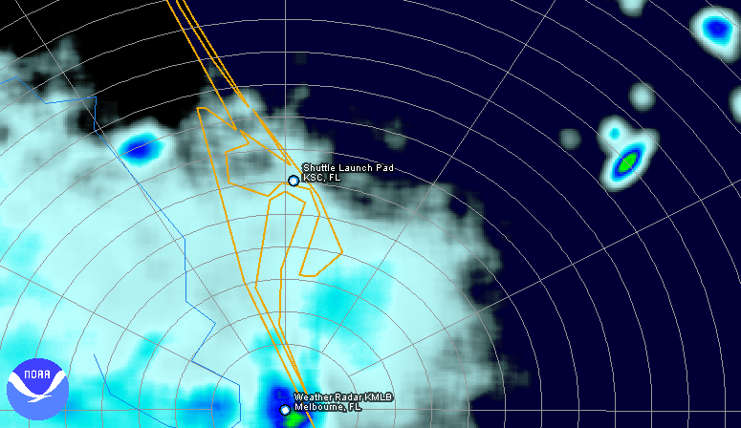
Big Question: Is it raining on the launch pad or in the flight path?
Fill in the weather data on the data-recording sheet from the Digital Weather Display. To launch there can be no precipitation at the launch pad or within the flight path. Write yes or no to determine if the weather conditions are within the weather launch commit criteria. Share your information with the meteorologist to determine whether the weather conditions will permit, delay, or scrub the launch.
Time | Humidity | Pressure  high 30+ or low 29.95- | Sky Conditions | Weather | Is the precipitation within Launch Commit Ranges? Launch? Yes/No
Example | 90% | 29.90 | Cloudy | Rain | No

Big Question: Will the temperature meet the Launch Commit Criteria for the shuttle launch?
Fill in the weather data on the data-recording sheet from the Digital Weather Display. Share your information with the meteorologist to determine whether the weather conditions will permit, delay, or scrub the launch.
Time | Temperature | Is the temperature  < 99 degrees Fahrenheit (F) for more than 30 minutes? > 48 degrees F? | Sky Conditions | Temp and sky conditions  within launch commit ranges?  Yes/No
Example | 70°F | _____ < 48 < 70° < 99 < ______ | Clear | Yes
 |  | ______< 48 < ______< 99 <_____
 |  | ______< 48 < ______< 99 < _____
 |  | ______< 48 < ______< 99 < _____
 |  | ______< 48 < ______< 99 < ____
 |  | ______< 48 < ______< 99 < _____
 |  | ______< 48 < ______< 99 < _____
 |  | ______< 48 < ______< 99 < _____
 |  | ______< 48 < ______< 99 < ____
 |  | ______< 48 < ______< 99 < _____
 |  | ______< 48 < ______< 99 < ____
 |  | ______< 48 < ______< 99 < _____

Big Question: Will clouds stop the launch?
Does the digital display show that there are clouds? If yes, look at the radar to fill in the chart. Share your information with the Meteorologist to determine whether the weather conditions will permit, delay, or scrub the launch.
Time | Cloud thickness  Transparent  (see-through)  or Opaque (solid)  1 | Transparent = yes  Opaque =  no  2 | Distance in miles of the cloud from the flight path  3 | Greater than 5 = yes  Less than or equal to 5 = no  Launch? Yes/No  4 | Do the clouds hold precipitation/ lightning or thunder?  5 | You must have  yes in column 4  and no in 5 to launch  Launch? Yes/No  6
Example | Opaque | No | 10 miles | Yes | No | Yes
Big Question: Is it raining on the launch pad or in the flight path?
Fill in the weather data on the data-recording sheet from the Radar Display. To launch there can be no precipitation at the launch pad or within the flight path. Share your information with the Meteorologist to determine whether the weather conditions will permit, delay, or scrub the launch.
Time | Clouds | Intensity of Precipitation  (color) | Intensity of precipitation  (dBZ-decibels) | Is precipitation within launch commit ranges  Launch? Yes/No
Example | Yes | Green | 30 dBZ | No

