` READING: Weather (Level 1)

1. Launch Weather Overview
The launch weather guidelines for the Space Shuttle and expendable rockets are the same in many areas, but are different for the individual parts. It is very important to review the conditions for each launch with great care to avoid the possibility of weather conditions that could harm the shuttle or human life.

For the Space Shuttle, three locations provide weather information:
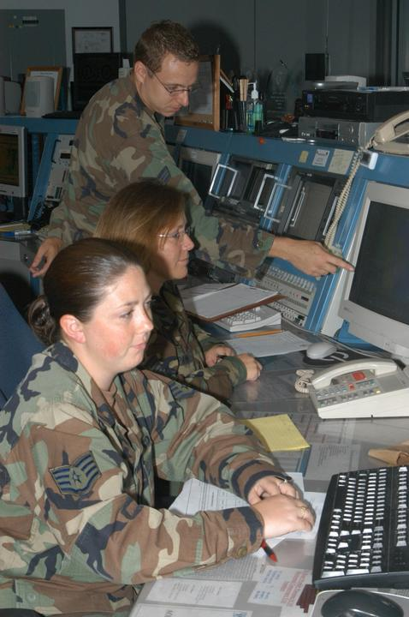
- Patrick Air Force Base, Cape Canaveral, FL: U. S. Air Force Range Weather Operations Facility
- Johnson Space Center in Houston, Texas: (NOAA) National Weather Service Space Flight Meteorology Group (SMG)
- Melbourne, Florida (KMLB): National Weather Service (NWS)

The first two-day reports include weather developments and their possible effects on launch day. A formal pre-launch weather briefing is held on Launch minus 1 day, which is a specific weather briefing for all areas of Space Shuttle launch operations.

The Range Weather Operations Facility and Melbourne prepare the launch weather forecasts, ground operations forecasts, and launch weather briefings for the Mission Management Team and the Space Shuttle Launch Director. The Space Flight Meteorology Group (SMG) prepares forecasts, which apply after launch. These include all emergency landing forecasts and the end of mission forecasts briefed by SMG to the astronauts, the Flight Director and Mission Management Team.

During the countdown, formal weather briefings occur approximately as follows:

L (Launch)-24 hr 0 min: Briefing for Flight Director and astronauts
L-21 hr 0 min: Briefing for removal of Rotating Service Structure
L-9 hr 00 min: Briefing for external tank fuel loading
L-4 hr 30 min: Briefing for Space Shuttle Launch Director
L-3 hr 55 min: Briefing for astronauts
L-2 hr 10 min: Briefing for Flight Director
L-0 hr 35 min: Briefing for launch and RTLS (Return To Launch Site)
Acronym Review
SMG: Space Flight Meteorology Group at Johnson Space Center in Houston, Texas
JSC: Johnson Space Center in Houston, Texas
KSC: Kennedy Space Center, Florida
NOAA: National Oceanic and Atmospheric Association
NWS: National Weather Service
KMLB: NWS Melbourne Station
RTLS: Return to Launch Site

Read the following press release from Patrick Air Force Base to get a feel for weather information on Launch Day.

PRESS RELEASE
Date Released: Wednesday, April 20, 2005
Source: Air Force News Service http://www.af.mil/news/

By Tech. Sgt. Lisa Luse
45th Space Wing Public Affairs

4/19/2005 – PATRICK AIR FORCE BASE, Fla. (AFPN) – Airmen of the 45th Weather Squadron here methodically calculates and determines if weather will threaten a future shuttle launch. Rain, lightning, wind, and cloud coverage can instantly delay or "scrub" any shuttle, mission or rocket launch.

"We have temperature, wind and rain constraints (because of) the height of a vehicle," said Capt. Mike McAleenan, the squadron's launch weather officer. "All launches have the same constraints."
Keyword Review
Methodically: thoroughly, systematically, logically
Constraints: restrictions, limits
Consecutive: uninterrupted, repeated, successive
Monitored: checked, watched, observed, keep an eye on
Standardize: control, adjust, regularize
Visibility: ability to see

Temperatures that go as high as 99 degrees for more than 30 consecutive minutes are considered too high to launch a vehicle. On the other hand, very low temperatures that are 48 degrees or lower also require an evaluation (estimate) of the wind as a combined concern for the vehicle.

Sometimes, experts look for more than one condition that could cause problems for the launch.

"More complicated is the combined effect of the temperatures that involve wind, temperature and rain that has to be determined," said Kathy Winters, the squadron's shuttle launch weather officer. "We use a table to evaluate these conditions and average the results."
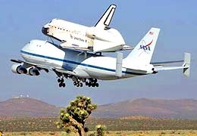
Natural and triggered lightning restrictions include evaluating clouds and weather within 11.5 miles of the launch pad. Along with lightning, the rain can also have a damaging affect on the shuttle as rain hits the outside of the spacecraft, the beads of water can be like small rocks hitting the side. As the rain freezes, ice forms on the surface. If the surface is damaged or changed, the difference could affect the structure enough to dangerously change direction and turn it off course, officials said.

"Any cloud within (11.5 miles) is closely monitored," Ms. Winters said. "We have all of these different measurements of miles to standardize all launches. The main-focus is within the 10-mile range. The peak wind constraint is (about 26 to 39 mph), depending upon the direction of the wind."
If the shuttle does not land at Kennedy Space Center, a "ferry flight" brings it back on top of a modified Boeing 747. Weather conditions for this flight are also critical.

Heavy cloud coverage can affect the visibility of the cameras designed to keep an "eye" on various parts of the shuttle. Space Shuttle Discovery has new cameras that view and detect any debris that may fall off or around the shuttle during flight. There is a new external fuel tank design for Discovery that officials said they will be closely watching.

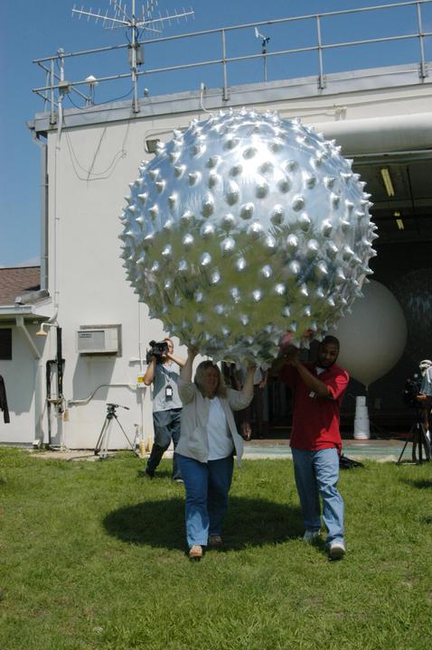
Officials have also added more ground cameras to watch the shuttle as it lifts off. Cameras are set up along the coast, just north and south of the launch pad. There are also two aircraft that will fly at 55,000 feet to take photos from their perspective.

"Observation of the upper air with balloons will check the wind, temperature, and rain of the area," Ms. Winters said. "We also provide weather updates … to coordinate any search and rescue that may be necessary."

Before they pass their forecast to officials, the weather team gathers bits of information from many sources to develop their idea of a picture-perfect successful launch.
Air balloons are frequently used to gather weather updates.

"Whenever any spacecraft is exposed to the elements, we will make sure the weather is compatible for the flight," Ms. Winters said. "We provide 24/7 weather resource protection."

There are three transoceanic abort landing sites where weather forecasters take complete surface and upper-air observations. The three sites are located at Istres, France; and Zaragoza and Moron, Spain.

In the next section we will look at what type of weather information is gathered and how it is observed.

2. Looking at the Weather Conditions
Sky Conditions
As we form our teams we need to carefully monitor rain, lightning, wind and cloud coverage. Remember these weather elements can instantly delay or "scrub" any shuttle, mission or rocket launch.
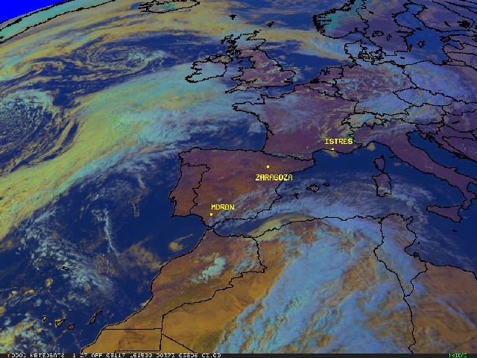
As you monitor the weather display, carefully observe clouds within 11.5 miles of the launch pad. The main-focus is within the 10-mile range. The peak wind constraint is (about 26 to 39 mph), depending upon the direction of the wind." Along with lightning, the rain can also have a damaging affect on the shuttle as rain hits the outside of the spacecraft, the beads of water can be like small rocks hitting the side. As the rain freezes, ice forms on the surface of the launch vehicle. If there is a change or damage to the vehicle, launch officials say that the difference could affect the structure enough to dangerously change direction and turn it off course.

Heavy cloud coverage can affect the visibility of the cameras designed to keep an "eye" on various parts of the shuttle. Space Shuttle Discovery has new cameras in place for its scheduled May 15 launch, Captain McAleenen said. It will be the first shuttle launch since Space Shuttle Columbia broke apart on re-entry in 2003. The cameras view and detect any debris that may fall off or around the shuttle during flight. There is a new external fuel tank design for Discovery that officials said they will be closely watching.

Ground Conditions
Temperature is also very important because of the height of the shuttle.

Remember that” temperatures that go as high as 99 degrees for more than 30 consecutive minutes are too high to launch a vehicle. On the other hand, very low temperatures that are 48 degrees or lower also require an evaluation of the wind as a combined concern for the vehicle.”

"More complicated is the combined effect of the temperatures that involve wind, temperature and rain that has to be determined," said Kathy Winters, the squadron's shuttle launch weather officer. "We use a table to evaluate these conditions and average the results."

What to look for:
- Rain and Lightning in clouds and heavy clouds that effect camera visibility
In the
11.5 mile range – all clouds
10-mile range – main focus
- Peak Winds – 26-39 mph
- Temperature:
< 99 degrees Fahrenheit (F) for more than 30 minutes
> 48 degrees F

Wind Speed |  |  | Relative Humidity
(kts) | 0-64% | 65-74% | 75-79% | 80-89% | 90-100%
0 - 1 | 48 | 47 | 46 | 45 | 44
2 | 47 | 46 | 45 | 44 | 43
3 | 41 | 41 | 41 | 40 | 39
4 | 39 | 39 | 39 | 39 | 38
5 - 7 | 38 | 38 | 38 | 38 | 38
8 - 14 | 37 | 37 | 37 | 37 | 37
>14 | 36 | 36 | 36 | 36 | 36

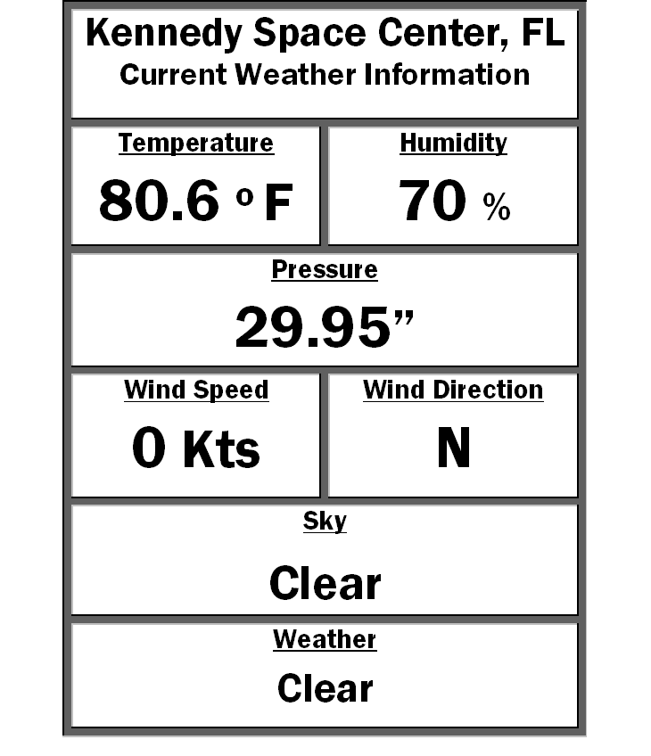
3. Monitoring Weather Conditions Using the Weather Display
Monitoring Sky Conditions
How do we look at sky conditions? In the last section, Kathy Winters talked about weather balloons that check the wind, temperature, and rain in the upper air of the area. In KLASS, the Digital Display/change to Weather Console shows several windows that provide different displays of weather conditions.

These are
- The Digital Display of the weather information from the weather balloons,
- The Radar Display for Nexrad radar information,
- The Lightning Display for lightning strike information, and
- The Satellite Image Display for information from the GOES weather satellite.
The KLASS Digital Display

The Digital Display
The Digital Display tells you the current temperature, humidity, pressure, wind speed and wind direction, as well as the conditions of the sky. This information is gathered by the weather balloons and relayed to the display for you to be able to analyze current launch sky conditions.

Temperature
Temperature is the measure of how hot or how cold the air is. Temperature on the display is measured is in degrees Fahrenheit. Remember to launch the shuttle; the temperature cannot be warmer than 99 degrees F for more than 30 minutes or less than 48 degrees F.

Humidity
Humidity is the amount of water vapor in the air. Humidity does not have to be 100% for it to be raining. However, it does have to be 100% where the clouds are forming and in the clouds that the rain is coming from. Clouds are formed when water from the earth evaporates into the air and then the air rises and cools. The water that is evaporating into the air is becomes the water vapor (e-vapor-ate) in the air that we call humidity. The more water in the air, the more humidity there is. As clouds form, the clouds gather more and more water until they become supersaturated and the water falls from the clouds as precipitation. The higher the humidity the more likely it is to have clouds in the sky and rain.

Barometric Pressure
Pressure refers to the “weight” of the air pressing down on the Earth, the ocean and on the air below. Earth's gravity is the downward force that we call "weight." Air pressure becomes less the higher you go in the atmosphere, because there is less air to “weigh” you down. Air pressure is one of the most important factors that determine the weather. Air pressure changes with the weather. High pressure is usually associated with good weather and low pressure is usually associated with rain and storms.

You can do some basic weather forecasting by using the wind and barometric pressure.

Barometric Pressure, Wind Speed and Direction
The National Weather Service provided information in the following table for a prediction of weather based on wind and barometric pressure.

Wind Direction | Barometric Pressure Reading | Barometric Pressure Trend | Weather
SW to NW | 30.10 to 30.20 | and steady | Fair with slight temperature change for 1 to 2 days
SW to NW | 30.10 to 30.20 | and rising rapidly | Fair, followed within 2 days by rain
SW to NW | 30.20 and above | and stationary | Continued fair, with no decided temperature change
SW to NW | 30.20 and above | and falling slowly | Slowly rising temperature and fair for 2 days
S to SE | 30.10 to 30.20 | and falling slowly | Rain within 24 hours
S to SE | 30.10 to 30.20 | and falling rapidly | Wind increasing in force, with rain within 12 to 24 hours
S to E | 29.80 or below | and falling rapidly | Severe storm imminent, followed within 24 hours, by clearing, and in winter by colder
SE to NE | 30.10 to 30.20 | and falling slowly | Rain in 12 to 18 hours
SE to NE | 30.10 to 30.20 | and falling rapidly | Increasing wind, and rain within 12 hours
SE to NE | 30.00 or below | and falling slowly | Rain will continue 1 to 2 days
SE to NE | 30.00 or below | and falling rapidly | Rain, with high wind, followed, within 36 hours by clearing, and in winter by colder
E to NE | 30.10 and above | and falling slowly | In summer, with light winds, rain may not fall for several days
E to NE | 30.10 and above | and falling slowly | In winter, rain within 24 hours
E to NE | 30.10 and above | and falling rapidly | In summer, rain probably within 12 to 24 hours
E to NE | 30.10 and above | and falling rapidly | In winter, rain or snow, with increasing winds, will often set in when the barometer begins to fall and the wind sets in from the NE
E to N | 29.80 or below | and falling rapidly | Severe northeast gale and heavy precipitation; in winter, heavy snow, followed by a cold wave
S to SW | 30.00 or below | and rising slowly | Clearing within a few hours and fair for several days
Going to W | 29.80 or below | and rising rapidly | Clearing and colder

Radar
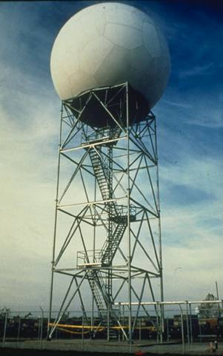
When cloud particles become too heavy to remain suspended in the air, they fall to the earth as precipitation. Precipitation occurs in a variety of forms; hail, rain, freezing rain, sleet, or snow. It is very important to be able to monitor clouds and precipitation for the Shuttle Launch.
The most successful tool to detect precipitation is radar. Radar stands for RAdio Detection And Ranging. Radar has been used to detect precipitation, and especially thunderstorms, since the 1940s.
The radar used by the National Weather Service is called NEXRAD or Nexrad (Next-Generation Radar) Its technical name is WSR-88D, which stands for Weather Surveillance Radar - 1988 Doppler (the prototype radar was built in 1988). As its name suggests, the WSR-88D is a Doppler radar, meaning it can detect motions toward or away from the radar as well as the location of precipitation areas. NEXRAD detects precipitation and wind.
Exactly how does radar work?
As the radar antenna turns, it emits (sends) extremely short bursts of radio waves, called pulses. Each pulse lasts about 0.0000016 seconds, with a 0.00019-second "listening period" in between. The transmitted radio waves move through the atmosphere at about the speed of light.

By recording the direction in which the antenna point, the direction of the target is known as well. Generally, the better the target is at reflecting radio waves (i.e., more raindrops, larger hailstones, etc.), the stronger the reflected radio waves, or echo, will be.
The Doppler Advantage
By their design, Doppler radar systems can provide information regarding the movement of targets, as well their position. When the WSR-88D transmits a pulse of radio waves, the system keeps track of the phase (shape, position, and form) of the transmitted radio waves.
There are 158 NEXRAD/WSR-88D Doppler radar in the nation, including the U.S. Territory of Guam and the Commonwealth of Puerto Rico, operated by the National Weather Service and the Department of Defense.
By measuring the shift in phase (the change in the shape, position, or form) between a transmitted (sent) pulse and a received echo, the target's radial velocity (the movement of the target directly toward or away from the radar) can be calculated. A positive phase shift implies motion toward the radar and a negative shift suggests motion away from the radar. The larger the phase shift, the greater the target's radial velocity.
Keyword Review
dBZ: stands of decibels of Z. It is a weather measure of equivalent reflectivity (Z) of a radar signal reflected off a remote object.
Echo: Radio waves reflected from the location targeted by the radar antenna.
Inbound Velocity: The speed an object moves toward your location.
KT: Knot or Nautical mile. One knot equals 1.1508 miles per hour .
Outbound Velocity: The speed an object moves away from your location.
Pulse: Short bursts of radio waves sent by the radar antenna.
Phase: Shape, position, and form.
Reflectivity: A display of echo intensity measured in dBZ.
Shift in phase: The change in the shape, position, or form.

Inbound Velocity = Positive Shift
An object sending waves will transmit those waves in a higher frequency when it is approaching your location as the waves are compressed (packed together).

Outbound Velocity = Negative Shift
As the object moves away from a location, the sound waves will be stretched and have a lower frequency. You have probably heard this as a sound effect when a fire truck drove past you with its siren blaring. As the fire truck passed your location, the pitch of the siren lowered as it moved away.

Scanning the Horizon
The NEXRAD/WSR-88D employs scanning strategies in which the antenna automatically raises to higher and higher preset angles, or elevation slices, as it rotates. These elevation slices comprise a volume coverage pattern or VCP. Once the radar sweeps through all elevation slices a volume scan is complete.

Volume Coverage Patterns (VCPs)
The radar continuously scans the atmosphere by completing volume coverage patterns (VCP). A VCP consists of the radar making many 360° scans of the atmosphere, sampling a set of increasing elevation angles.

There are two main operating states of the NEXRAD/WSR-88D; Clear Air http://ww2010.atmos.uiuc.edu/(Gh)/guides/rs/rad/basics/sgnl.rxml

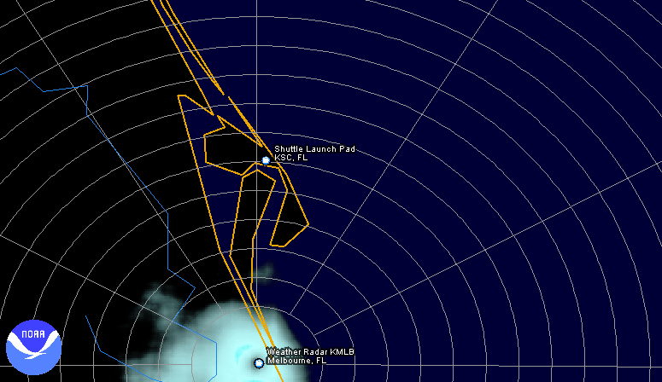
Mode and Precipitation Mode. Within these two operating states there are several VCPs the NWS forecasters can utilize to help analyze the atmosphere around the radar. Each VCP can provide a different perspective of the atmosphere.
Clear Air Mode
Clear Air mode is used when there is no rain within the range of the radar. In this mode, the radar is in its most sensitive operation state. This mode has the slowest antenna rotation rate which permits the radar to sample a given volume of the atmosphere longer. This increased sampling increases the radar's sensitivity and ability to detect smaller objects in the atmosphere than in precipitation mode.
A typical radar image in clear air mode will not reveal much. Generally, the only returned energy to the radar will be very close to the radar's location. A lot of what is seen will be airborne dust, and bugs.

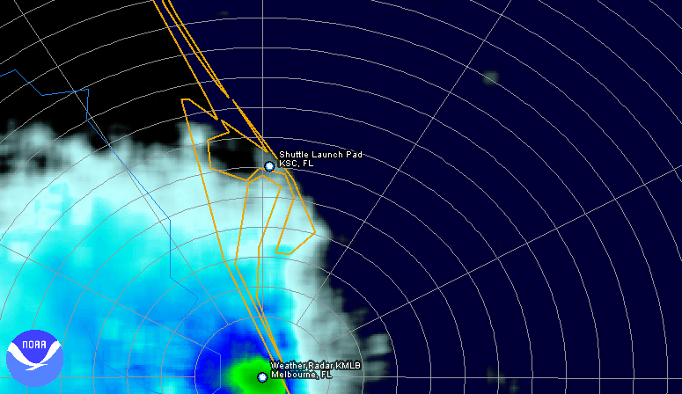
Precipitation Mode
When precipitation is occurring, the radar does not need to be as sensitive as in clear air mode as rain provides plenty of returning signals. At the same time, meteorologists want to see higher in the atmosphere when precipitation is occurring to analyze the make-up of the storms straight above the location on the ground. This is when the meteorologists switch the radar to precipitation mode.

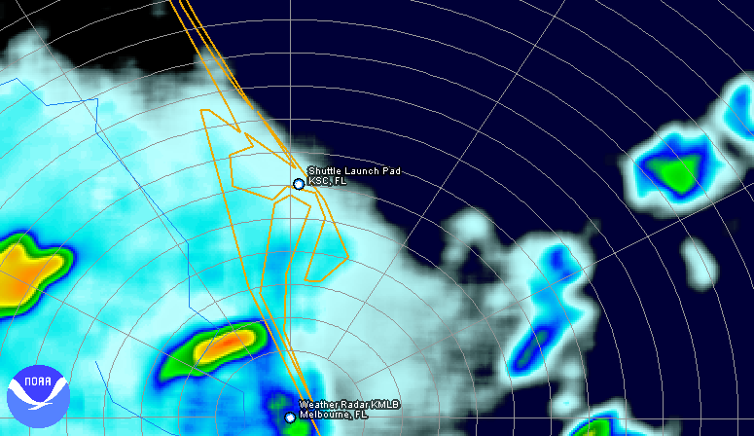
The radar image above shows cloud cover. The green area is the energy of the dust, bugs, etc that is close to the radar at Melbourne NWS (KMLB). The blue and white further away is the cloud cover between Melbourne’s radar and Kennedy Space Center.

In this radar image you can see clouds and rain. The “hotter” colors (yellow, orange, red) on this image show stronger “stormy” precipitation.
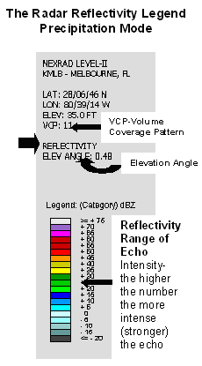
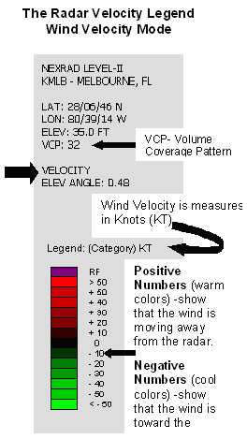

Radar and Wind
NEXRAD detects not only clear air and precipitation, but also wind velocity. Wind can cause problems for a shuttle launch. Tanking will not begin if the wind is observed or forecast to exceed 42 knots for three hours before tanking. The peak wind speed allowable at the launch pad is 30 knots. The Shuttle Weather Officer gives a downrange weather advisory to the Mission Management Team to think about if the wind forecast in the solid rocket booster recovery area states that the wind might exceed 26 knots during recovery operations.

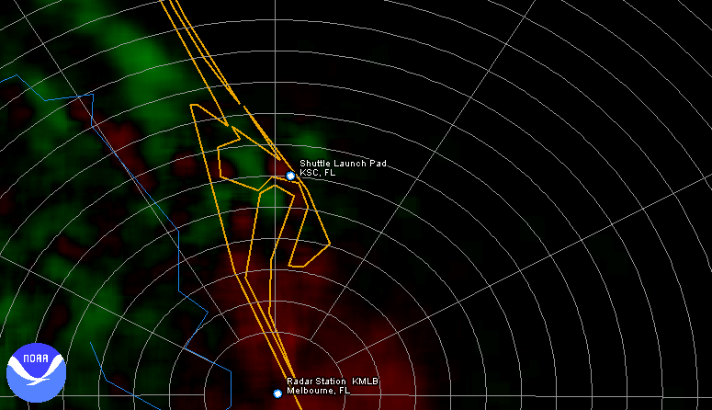
What is this radar image saying? If you look at the legend on the right, you can see that the winds are green north of Kennedy Space Center, which means that they are moving south toward the radar at Melbourne’s NWS’ station KMLB. The winds are red near Melbourne are moving away from the radar. In addition, the colors in the legend at the right help you to tell what the wind speed is in KTs (knots or nautical miles).

What color would the radar show for winds that are >50 Kts moving away from the radar? What color would you see on the radar for winds < 50 Kts knows moving toward the radar?

Lightning
Did You Know?
- Lightning strikes somewhere on the surface of the earth about 100 times every second.
- Each spark of lightning can reach over five miles in length, soar to temperatures of approximately 50,000 degrees Fahrenheit, and contain 100 million electrical volts.
- At any given moment, there are 1,800 thunderstorms in progress somewhere on the earth. This amounts to 16 million storms each year!
- There are lightning detection systems in the United States and they monitor an average of 25 million flashes of lightning from the cloud to ground every year!
In the United States, on average lightning kills 66 people each year. In 2005, there were 43 deaths confirmed deaths and 172 confirmed injuries. The injury number is likely far lower than it should be because many people do not seek help or doctors do not record it as a lightning injury.

People struck by lightning suffer from a variety of long-term, disturbing symptoms, including memory loss, attention deficits, sleep disorders, numbness, dizziness, stiffness in joints, irritability, fatigue, weakness, muscle spasms, depression, and an inability to sit for long.

The Most Common Types of Lightning
Cloud-to-ground lightning is the most damaging and dangerous form of lightning. Although cloud-to-ground lightning is not the most common type of lightning, it is the best-understood lightning. Most flashes originate near the lower-negative charge center and deliver negative charge to Earth. However, positive flashes often occur during the dissipating stage of a thunderstorm's life. Positive flashes are also more common as a percentage of total ground strikes during the winter months.

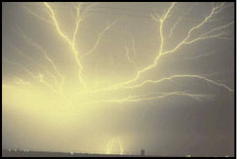
Intra-cloud lightning is the most common type of discharge. This occurs between oppositely charged centers within the same cloud. Usually the process takes place within the cloud and looks from the outside of the cloud like a diffuse brightening which flickers. However, the flash may exit the boundary of the cloud and a bright channel, similar to a cloud-to-ground flash, can be visible for many miles.

The ratio of cloud-to-ground and intra-cloud lightning can vary significantly from storm to storm. Storms with the greatest vertical development may produce intra-cloud lightning almost entirely.

Details of why a discharge stays within a cloud or comes to ground are not understood. Perhaps a flash spreads toward the Earth when the electric field slope in the lower regions of the cloud is stronger in the downward direction.

Depending upon cloud height above ground and changes in electric field strength between cloud and Earth, the discharge stays within the cloud or makes direct contact with the Earth. If the field strength is highest in the lower regions of the cloud, a downward flash may occur from cloud to Earth.

Inter-cloud lightning, as the name implies, occurs between charge centers in two different clouds with the discharge bridging a gap of clear air between them.
How far away is lightning from me?
To estimate the distance between you and a lightning flash, use the "Flash to Bang" method: If you observe lightning, count the number of seconds until you hear thunder. Divide the number of seconds by five to get the distance in miles.

Example: If you see lightning and it takes 10 seconds before you hear the thunder, then the lightning is 2 miles away from you (10 divided by 5 = 2 miles).

If Thunder is heard... | The Lightning is...
5 seconds after a Flash | 1 mile away
10 seconds after a Flash | 2 miles away
15 seconds after a Flash | 3 miles away
20 seconds after a Flash | 4 miles away
25 seconds after a Flash | 5 miles away
30 seconds after a Flash | 6 miles away
35 seconds after a Flash | 7 miles away
40 seconds after a Flash | 8 miles away

Lightning At Kennedy Space Center
Lightning is a serious danger. You can imagine that lightning is a serious weather problem for launching the shuttle.

The avoidance of lightning strikes to a spacecraft during launch relies heavily on the ability of meteorologists to accurately forecast and interpret lightning hazards to NASA vehicles under varying weather situations. Severe hazards for NASA due to lightning are well known. In 1969 during the Apollo 12 launch lightning briefly knocked out vital spacecraft electronics. Fortunately, the astronauts regained control. The threat of lightning causes many work stoppages and lost production increasing the time and cost required to prepare NASA spacecraft for flight.

Kennedy Space Center (KSC) runs far-reaching lightning protection and detection systems in order to keep its employees, the 184-foot high Space Shuttle, the launch pads and processing facilities, from harm. While the protection system is exclusively on KSC property, the detection system incorporates equipment and personnel both at the space center and Cape Canaveral Air Station (CCAS), located at Patrick Air Force Base just east of the Space Shuttle facility.

Predicting Lightning Before It Reaches KSC
U.S. Air Force Weather Group provides all weather information for the KSC/CCAS area. This information includes lightning advisories that are critical for day-to-day Shuttle processing, as well as launch day weather data essential in helping NASA determine when it is safe for the Space Shuttle to lift off. An Air Force staff meteorologist works permanently in the NASA/ KSC test director's office. He is also in the Launch Control Center during Space Shuttle launch preparations and countdown.

KSC operations and Air Force weather personnel have worked closely for several years to develop the Cape Canaveral Forecast Facility (CCFF), a center for the forecasting and detection of thunderstorms and other adverse weather conditions.

Lightning Detection Systems
The Launch Pad lightning observation systems provide data directly to the CCFF (Cape Canaveral Forecast Facility) on electrical activity in the atmosphere. These systems, along with weather radar, are the primary Air Force thunderstorm surveillance tools for evaluating weather conditions that lead to the issuance of lightning warnings. The data is valuable in detecting early storm electrification and the threat of triggered lightning for launch vehicles.

The lightning observation system detects, locates, and describes negative cloud-to-ground lightning within approximately 60 miles of the CCFF. Electromagnetic radiation produced from lightning is first detected by the system's three direction finder antennas located at Melbourne, Orlando, and in the northern area of KSC. Once the systems chart a lightning strike pattern on a map, it becomes easier for the forecaster to predict just where the next lightning bolts will hit.

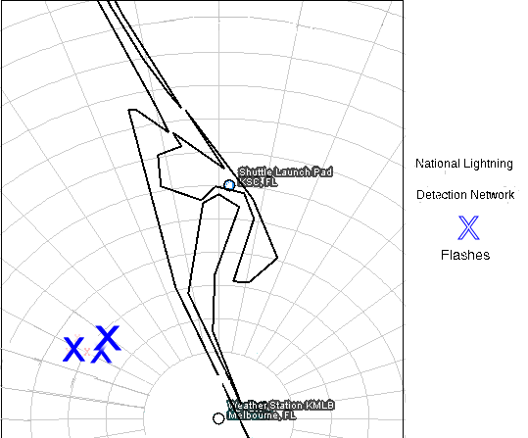
The Lightning Display
The KLASS Lightning Display is similar to the National Lightning Detection Network (NLDN) Display. The NLDN is a ground-based lightning detection network for the continental United States. NLDN detects cloud-to-ground lightning. This display was chosen for the ease of following lightning strikes. The radar image helps when looking the direction the clouds are moving and the intensity of the storm, while you monitor the flashes on the Lightning Display.

Satellite Imagery
The final weather display is Geostationary Operational Environmental Satellites (GOES) Visible Satellite Imagery. It helps to understand the cloud cover flood warnings, as well as estimates snowfall accumulations and overall extent of snow cover. Such data help meteorologists issue winter storm warnings and spring snow-melt advisories. Satellite sensors also detect ice fields and map the movements of sea and lake ice.

These satellites send weather data and pictures that cover various sections of the United States. Current weather satellites can transmit visible or infrared photos, focus on a narrow or wide area, and maneuver in space to obtain maximum coverage.

Visible Satellite Images
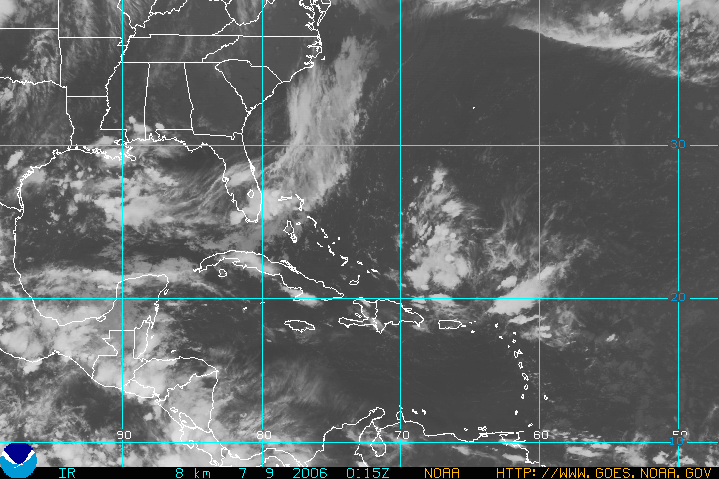
Visible satellite images are photographs of the earth that provide information about cloud cover. Areas of white indicate clouds while shades of gray indicate generally clear skies.

Visible images represent the amount of sunlight being scattered back into space by the clouds, aerosols, atmospheric gases, and the Earth's surface. Thicker clouds have a higher reflectivity (or albedo) and appear brighter than thinner clouds on a visible image. However, it is difficult to distinguish among low, middle, and high level clouds in a visible satellite image, since they can all have a similar albedo (reflectivity) and for this distinction, infrared satellite images are useful.

Learn More
- http://ww2010.atmos.uiuc.edu/(Gh)/guides/rs/sat/img/vis.rxml
- http://cimss.ssec.wisc.edu/satmet/index.html
- http://ww2010.atmos.uiuc.edu/(Gh)/wwhlpr/mie_scattering.rxml?hret=/guides/rs/sat/img/viw.rxml&prv=1

