TEACHER GUIDE: Using KLASS on Launch Day

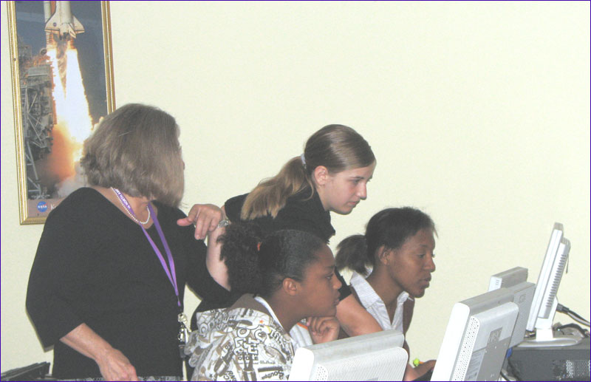

- Your KLASS Classroom Set-up
- A Suggested List of Activities for Launch Simulation Days

Team and Role Assignments

Responsibilities and Organizational Chart

Organizational Communication

Contingency Planning

I. Your KLASS Classroom Set-up

Whether you have worked through all levels of the KLASS software, or you are just starting at this point and want your students to experience the launch, this guide will help you plan and implement the simulation for your classroom.

When thinking through the set-up of your lab, take into consideration these factors:

How many students do you have in your class?
How many student computers are available?

The software CD contains specific directions for installing, networking, and setting up the KLASS software. For the design of the activities, you should know that minimally, the following networked computers are needed to run the simulation:

- 1 teacher console computer
- 1 student console

To run a simulation synchronized with the Shuttle launch video, the following equipment will be required:

- 1 teacher console computer
- 1 video computer with projection
- 1 student console

A basic configuration with five student consoles, a launch director console, a teacher console, and a video computer would look like the following illustration:

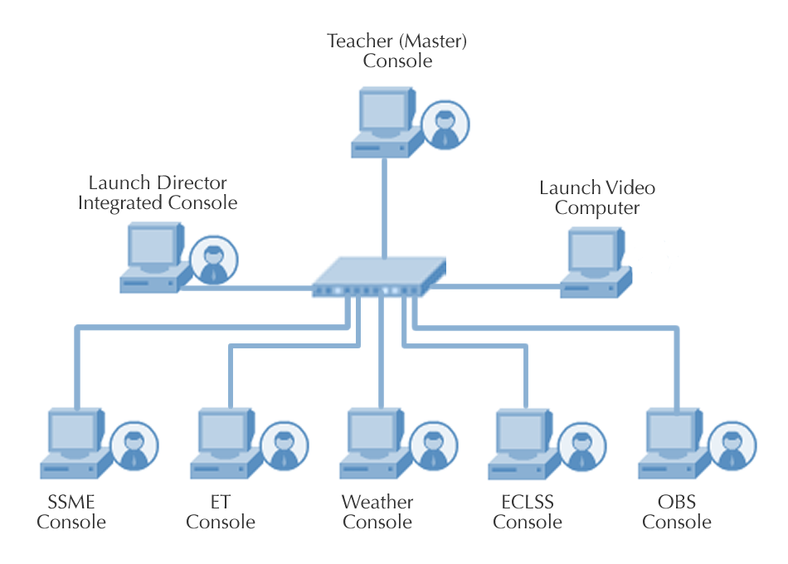

There are quite a few possibilities for setting up the simulation lab. There are 5 different KLASS student consoles. The SSME console is designed for 3 SSME engineers. In addition, the weather console has a primary view and 4 different views. There is also an integrated view that shows a summary of all systems.
Ideally, an integrated simulation set-up could include these items:
- 1 teacher console computer
- 1 video computer with projection
- 1 integrated view (launch director)
- 3 SSME consoles
- 1-2 ET consoles
- 1-4 Weather consoles (meteorologist, weather technicians, and launch weather officer)
- 1-2 ECLSS consoles
- 1-2 OBS consoles

The KLASS simulation has been tested in a classroom environment with as many as 12 computers. Starting with fewer computers is probably the best approach until you and your students become even more familiar with the program. Grouping students around each console could work with up to 3 students per computer. This depends on the activity and the level of your students.

It is important to note that in most cases there is very little student interaction with the software itself. So, while seeing the data is important, the actual student commands are limited. Therefore, using the activity sheets that are provided will allow up to 3 students to work together while monitoring data from the same computer/console.

II. A Suggested List of Activities for Launch Simulation Days

Team and Role Assignments
There are many different ways to break students into teams, depending on your class and teaching style. In the KLASS Console lesson in Level 1-Training, there is a sample application and tips for the application process. Below are some ideas for you to try when it is time to determine your team groupings.
- Have elections or set up an interview process for the various positions.
- Have your students determine how many positions and consoles there should be based on one or more of the activities below.
- Invite administrators or other teachers to be part of the selection committee for top job roles such as launch director or weather officer.
- If you don’t have enough computers, schedule lab time or borrow computers for the week or more you will run the simulation.
- If time permits, swap job/team roles as often as possible so everyone gets to experience the various consoles.

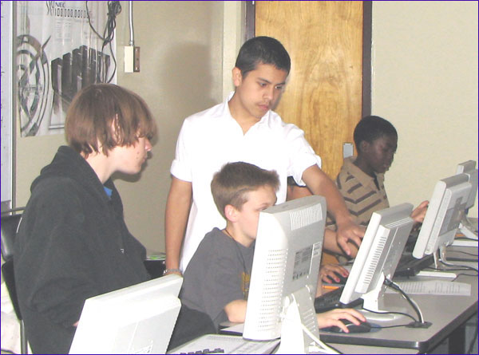

The activities in Level 1-Orientation, will help you and the students to build up to launch day. If you haven’t worked through those activities, review them now, pull a few out, and try them before running a full-blown, integrated launch.

Responsibilities and Organizational Chart
Have students brainstorm and define their core mission responsibilities via small group discussions. This ultimately will happen after teams are organized, and the mission has been revealed.

Ask the students the following questions and have them decide within their groups the best answers. Then, compare each group’s answers so everyone is best prepared.

- What materials will you need on launch day?
(Pencils, calculators, communication aids, scrap paper, schematics with target ranges, and Official NASA badge)

- What are the checkpoints?
(The KLASS countdown clock actually begins at T-04min 17sec. In those next 4 minutes during the simulation, what do they have to do? They should devise a detailed list of who does what and when.)
- How is the hold initiated?
(Students should determine who holds the launch for each team.)

- How will you report problems? Is there a hierarchy? How will you keep to a minimum the lines of communication to the LD?
(See the Organizational Communication activity on the next page.)

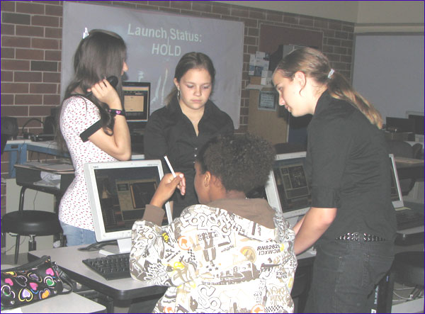

In the Missions Directorate lesson in Level 2-Orientation, there is a discussion regarding NASA’s organization structure. Reference this lesson as needed. The student groups should deliver an organization chart and plan for your approval or for the launch director’s input.

Organizational Communication
This activity will allow students to discuss how the line of communication will work during simulation. As you can imagine, NASA has a very organized communication protocol for launch day. There is a hierarchy established. For example, a weather technician may see a lightning spike. That weather technician won’t yell that out to the launch director. Instead, the weather technician will discuss it with the meteorologist. If the meteorologist believes it is appropriate, the launch weather officer will be notified. If the launch weather officer believes it is important, he or she will follow the communication protocols up the chain of command.

Ask the students to work through this chain of communication based on the specific job tasks of their teams. Directions to students:

As a team, you are going to figure out who communicates to whom, and when, during a launch countdown. As a group, you will discuss the roles and the chain of command. You also will discuss who will be in charge of updating the launch director. As well, you will determine who will issue a hold from your console and when that would happen. The end result will be a diagram of the consoles – a directed graph showing the flow of information.

To lead this discussion, try these questions:

- To which person or group is the most information flowing?

- Who delivers the most communications?

- Which teams work together? Are there any cliques (sub-graph)?

- Who is up front?

- The launch director is out front, then the weather people. Who is next?

- Where is the astronaut in all of this?

Try these possible follow up questions:

- Let’s talk about the hierarchy. LD is the top dog. SSME is over ET due to the responsibility involved. ECLSS has more responsibility than OBS. Weather has a hierarchy of its own. Do other consoles have an hierarchy?

- What will your team’s organization chart look like? (Revisit Mission Directorates lesson in Level 2-Orientation.)

- Once you have determined the members in your group, map your members according to the organizational chart. Have you accounted for everyone?
Students should produce flowcharts for their teams. This will prove to be a lively discussion!

Contingency Planning
Each member and group of NASA’s launch team has a very detailed Shuttle launch checklist that is followed. While those checklists are not included in KLASS materials because they wouldn’t apply, students should be able to think through various situations and map out contingency plans of their own.

Directions to students:

You have to know what can go wrong and how to react when it happens. In this activity, you will play out “what if” scenarios. Many situations that arise will affect more than 1 subsystem. If something happens in your area, who else will need to be notified?

Possible “What if?” questions:

- What if we have no fuel flow? Who is responsible for this?
(ET has to work with SSME to figure the cause and solution.)
- What if the astronaut’s heart rate or respiration was out of range? Who is responsible?
(OBS and ECLSS would both need to pay attention to this.)
- What if lightning was suddenly spotted in the area?
(Weather will have to brief LD, but there are also implications for the tanking teams.)
- What if the temperature drops rapidly and is approaching temperatures out of range from LCC?
- What if it begins to hail?
- What if the oxidizer has depleted?
(They’ll have to replenish, look for a leak, or cap it.)
- What if the LD develops chest pains and difficulty breathing?
- What if we’re not producing enough thrust?
- What if we blow a fan fuse in the cabin?
- What if one of the astronauts begins complaining about feeling dizzy?

Student teams will work through these scenarios and produce their contingency plans for the larger group. A checklist format might be the best way for them to submit this.

